Part B:
- Problem Statement: Finding the Average
  - Given a set of numbers, how can we find their average?
  - Example: Given the numbers [5, 8, 12, 4, 10], calculate the average.
First, we add everything that is in the list and take the sum of all of it then divide by the number of digits or numbers in that list, from the example we add [5, 8, 12, 4, 10], then divide by 5 to get the average of all the numbers.
- Develop pseudo code to solve the problem statement outlined in Step 1.
  - Use descriptive variable names and comments to enhance readability and understanding.
ALGORITHM CalculateAverage(numbers)
// Input: numbers - an array/list of numeric values
// Output: average - the arithmetic mean of the numbers
DISPLAY "Numbers entered: ", numbers
// Check if the input is valid
IF numbers is empty THEN
DISPLAY "Error: Cannot calculate average of an empty set"
RETURN
END IF
// Initialize variables
SET sum TO 0
SET count TO length of numbers
DISPLAY "Total numbers: ", count
// Calculate the sum of all numbers
FOR EACH number IN numbers DO
DISPLAY "Adding number: ", number
SET sum TO sum + number
DISPLAY "Current sum: ", sum
END FOR
// Calculate the average
SET average TO sum / count
// Output the result
DISPLAY "Final sum: ", sum
DISPLAY "Average: ", average
RETURN average
END ALGORITHM

- Write a Backus-Naur Form (BNF) grammar to describe the syntax of the problem statement.
BNF
<number-list> ::= <number> | <number> "," <number-list>
<number> ::= <integer> | <decimal>
<integer> ::= <sign>? <digit-sequence>
<decimal> ::= <sign>? <digit-sequence> "." <digit-sequence>
<sign> ::= "+" | "-"
<digit-sequence> ::= <digit> | <digit> <digit-sequence>
<digit> ::= "0" | "1" | "2" | "3" | "4" | "5" | "6" | "7" | "8" | "9"

- Construct a parse tree based on the BNF grammar to visualize the syntactic structure of the problem.
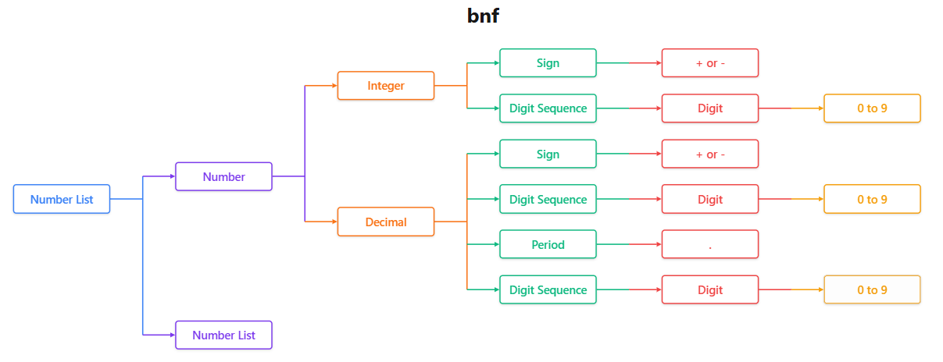

- Examine the parse tree constructed in Step 4 to determine if the BNF grammar is ambiguous.
  - Identify any areas where multiple interpretations are possible.

The BNF grammar is ambiguous mainly in the following areas:
a) <digit-sequence> rule
<digit-sequence> ::= <digit> | <digit> <digit-sequence>
This recursive definition allows more than one parse tree for the same string of digits (for example, 123), creating ambiguity in how the digits are grouped.
b) <number-list> rule
<number-list> ::= <number> | <number> "," <number-list>
This rule allows different groupings of numbers in a list, which can lead to multiple valid parse trees for the same input such as 1,2,3.

  - Provide examples or scenarios to illustrate potential ambiguities and their implications.

Example 1: Input 123
Using:
<digit-sequence> ::= <digit> | <digit> <digit-sequence>
The string 123 can be parsed in multiple ways:
As 1 (2 3)
As (1 2) 3
These different parse trees represent the same string but with different structures.
Implication: A parser may not know which structure to choose, leading to inconsistent or incorrect syntax trees.

- Rewrite the BNF grammar using Extended Backus-Naur Form (EBNF) to enhance readability and expressiveness.
  - Explain the benefits of using EBNF over traditional BNF, particularly in terms of readability and clarity.
Using EBNF improves readability for the reader and clarity overall since it allows grammar rules to be written in a more readable format and expressive in a way using the use of repetition and optionality operators. These features make the need for long and complex recursive definition obsolete, making the structure much easier to understand for the reader.
  - Remove any ambiguity present in the BNF grammar through syntax modifications in the EBNF version.
EBNF
<number_list> ::= <number> ("," <number>)*
<number> ::= <integer> | <decimal>
<integer> ::= "-"? <digit>+
<decimal> ::= "-"? <digit>+ "." <digit>+
<digit> ::= [0-9]

- Use the EBNF grammar to reconstruct a parse tree, demonstrating how the revised syntax resolves any ambiguities present in the original BNF grammar.
  - Analyze and compare the parse trees from Steps 4 and 7 to understand the impact of syntax modifications on the parse tree structure.
